Software Design Document (SDD)
INVENTORY MANAGEMENT SYSTEM



Submitted By
Muhammad Arham
(F22BINFT1M01160)
Supervisor
Ms. Sara Farid

Department of Information Technology
Faculty of Computing
The Islamia University of Bahawalpur

Revision History

Date | Detail | Writer | Remarks

Approval Page
This design document has been reviewed and formally approved by the following authorities:

Signature | Name | Title | Date

Table of Contents
1. Introduction 1
1.1 Aim 1
1.2 Project Coverage 1
1.3 General Description………………………………………… …………………………………...1
1.4 Source ………………………………………………………………………….……………………2
1.5 Definitions, Acronyms, and Abbreviations 2
2.System Summary…………………………….…………...……………………..……………….3
3. SYSTEM ARCHITECTURE 4
3.1 Design Sutructure ……………………………………………….…………………….…………….4
3.2 Decomposition Description 7
3.2.1 Data Flow Diagram 7
3.2.2 ER Diagram 9
3.2.3 Activity Diagram 10
3.2.3 Sequence Diagram 11
4. DATA DESIGN 13
5. USER INTERFACE DESIGN 14
5.1 Overview of User Interface 14
5.2 Screen Images 14
5.2.1 Home Screen 14
5.2.2 Login Screen 15
6. Appendices 15
6.1 References 15

1. Introduction

1.1 Aim
This document (SDD) explains the technical layout of the Inventory Management System. It provides a clear picture of how the system will be arranged, built, and connected. It is written for programmers, reviewers, and project members so they can easily understand how the system will be developed. It also describes design decisions, system parts, and how different sections will work together based on the requirement document.

1.2 Project Coverage

The Inventory Management System is an online solution developed to support small and medium shops in handling their daily work. It manages stock levels, sales records, purchase details, reports, and user access. By changing manual work into automatic processes, it saves time, lowers mistakes, and helps shop owners make better choices.
Main Capabilities:
- Continuous stock monitoring with warning alerts.
- Sales handling with bill creation and payment tracking.
- Supplier and purchase control.
- Secure login with user roles.
- Reports for business planning.
The system works through internet browsers and is designed to grow as business needs increase. Future versions may include mobile access and external connections.

1.3 General Description
This system offers a single platform for managing shop operations. Automation and central control reduce workload and increase accuracy. Managers and workers can use it easily through a clean and simple interface.
Targets:
- Provide a reliable and expandable system.
- Reduce paperwork through automation.
- Give useful business insights.
- Improve ease of use with role base access.
The system design follows modern standards of performance, safety, and accessibility. Its modular style allows easy updates later.

1.4 Sources
The following materials supported the system design:
- Online slides about store systems.
- Internet articles about web development.
- Online encyclopaedias for technical ideas.
- Learning sites for HTML, CSS, and PHP.
- Accessibility guidelines.
- International quality stander.•

1.5 Definitions, Acronyms, and Abbreviations
Acronym | Full Form | Definition
SRS | Software Requirements Specification | Requirement description document.
ER Diagram | Entity-Relationship Diagram | Database structure drawing.
DFD | Data Flow Diagram | Data movement chart.
POS | Point of Sale | Sales point system.
UI | User Interface | User interaction area.
RBAC | Role-Based Access Control | Access by role method.  .
WCAG | Web Content Accessibility Guidelines | Accessibility rules.
PHP | Hypertext Preprocessor | A server-side scripting language used for web development.
MDN | Mozilla Developer Network | An online resource providing documentation for web technologies.
GDPR | General Data Protection Regulation | Data privacy law.
IEEE | Institute of Electrical and Electronics Engineers | Engineering standards group.
PCI DSS | Payment Card Industry Data Security Standard | Payment safety rules.
HTML | Hypertext Markup Language | A markup language used for creating web pages.
CSS | Cascading Style Sheets | Page design language.
MySQL | My Structured Query Language | Database software.
XAMPP | Cross-Platform, Apache, MariaDB, PHP, and Perl | Local server tool.

2. System Summary
The Inventory Management System is a flexible web-based platform that joins stock, sales, purchases, and reports in one place. It supports smooth daily operations for shop staff and owners.
Main Sections:
Stock Control:
- Livestock updates.
- Low-stock alerts.
- Product Grouping.
Sales Control:
- Fast selling process.
- Bill and payment records.
- Sales performance reports.
Purchase Control:
- Supplier data handling.
- Order and restock tracking.
Reports:
- Sales and stock summaries.
- Planning support data.
Users:
- Different permission levels.
- Protected login system.

3. SYSTEM ARCHITECTURE
3.1 Design Structure
The system follows a layered design to improve speed, safety, and maintenance.
Layers:
Interface Layer:
- Screens for admin and staff.
- Works on modern browsers.
- Ready for mobile later.
Logic Layer:
- Controls system rules.
- Built with PHP and JavaScript.
Storage Layer:
- MySQL database.
- Organized tables for fast access.
Deployment:
- Runs on Apache server.
- Backup and recovery support.
Overall Flow:
User → Web Server → Database

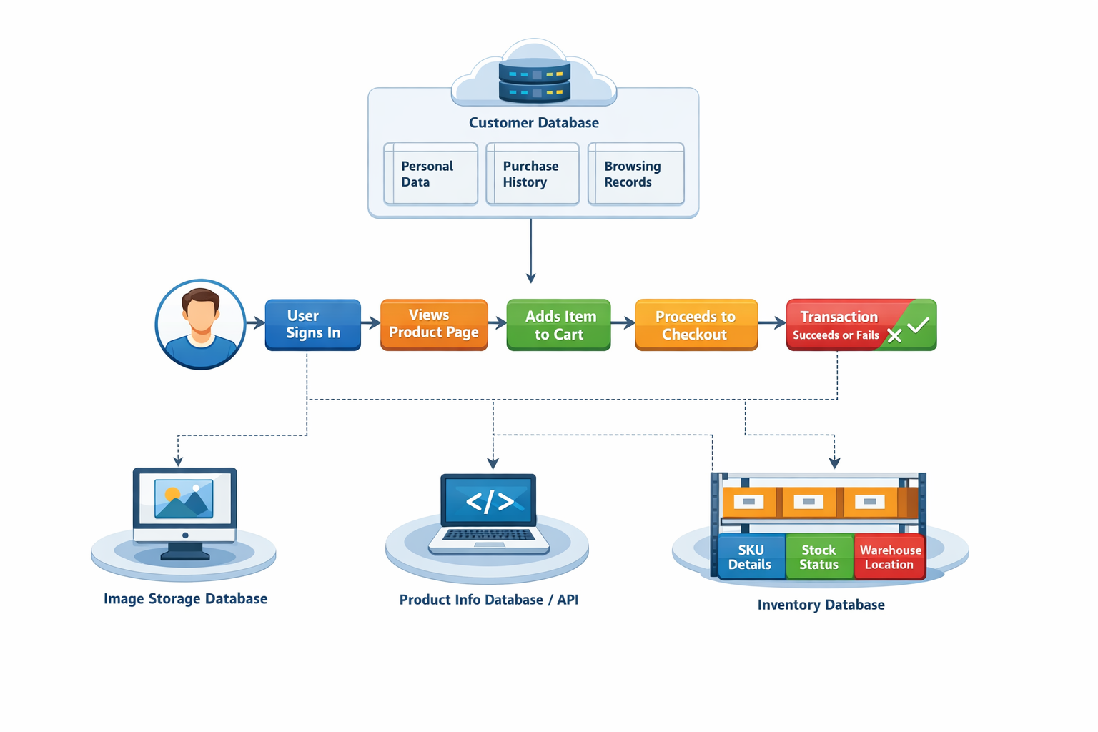

3.2 Decomposition Description

3.2.1 Data Flow Diagram
A Data Flow Diagram (DFD) is a visual tool that shows how data moves through a system. It illustrates the transformation of input data into output data through various processes, while also depicting the interactions between processes, data stores, and external entities (such as users or other systems).

3.2.1.1 Context level Data Flow Diagram (DFD)

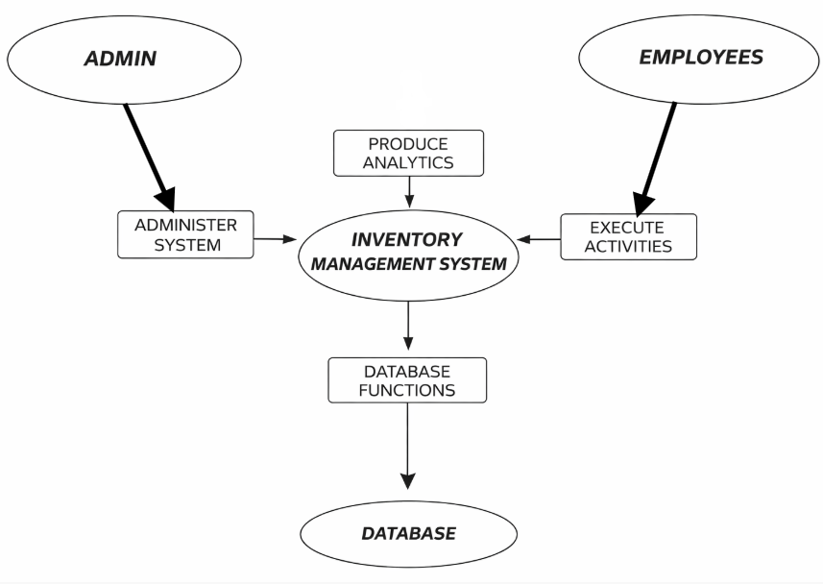

Figure 3.2.1.1: 0 Level Diagram

3.2.1.2 Level 1 Data Flow Diagram (DFD)

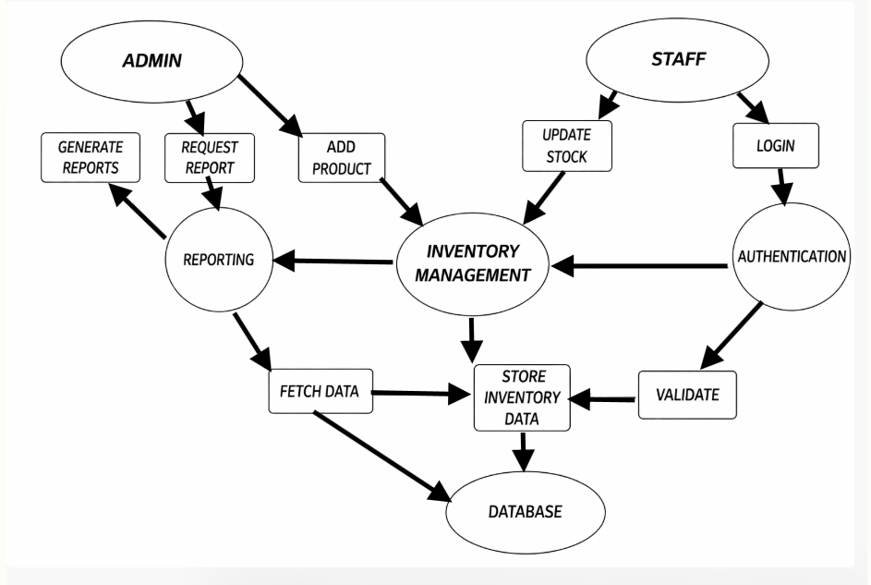

Figure 3.2.1.1: 1 Level Diagram

3.2.2 ER Diagram
An Entity-Relationship (ER) Diagram is a conceptual modeling tool that graphically represents the entities relevant to a system, along with the relationships that exist among them. It serves as a foundational step in database design, providing a clear blueprint that can be systematically converted into a relational database schema.
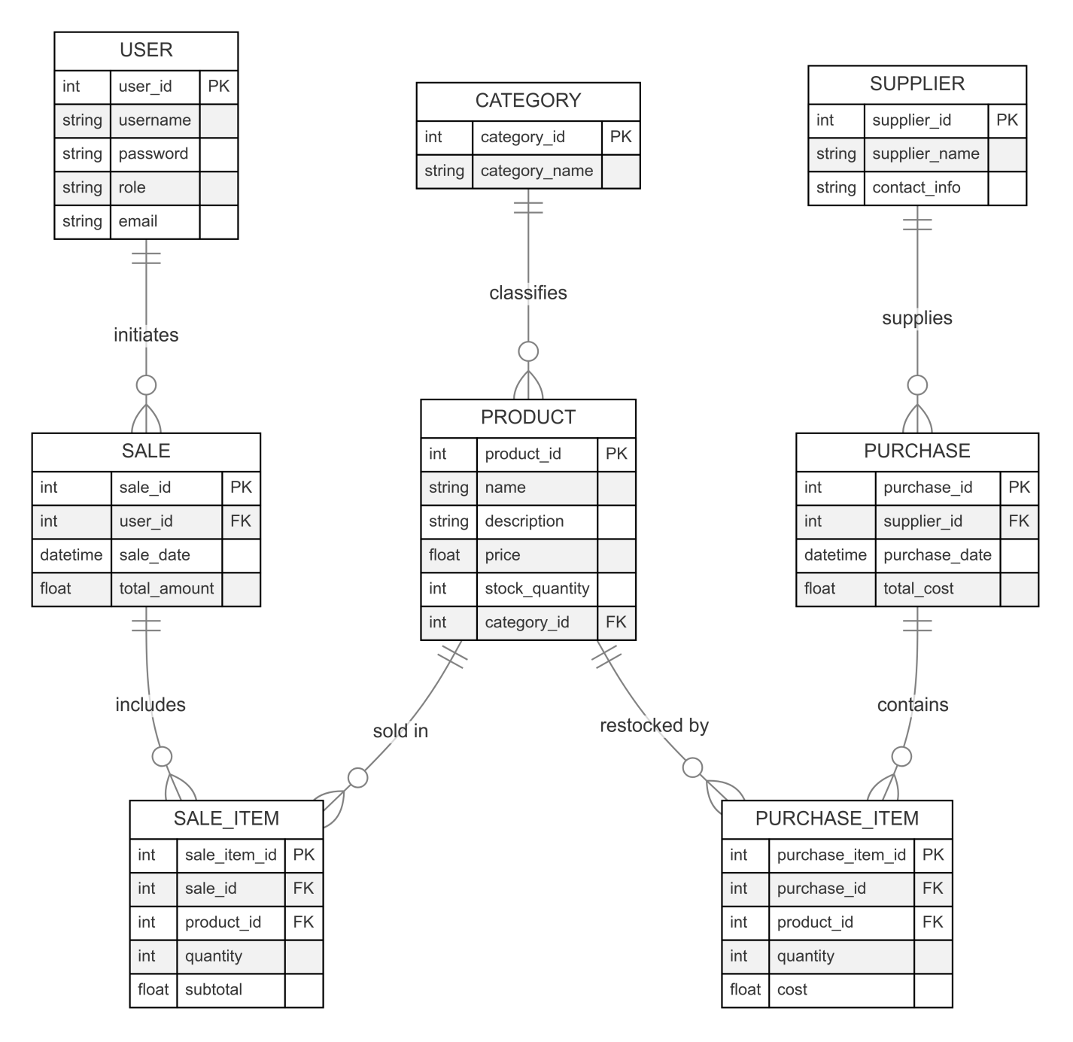Figure 3.2.2: ER Diagram

3.2.3 Activity Diagram
An Activity Diagram is a UML diagram that visually shows the step-by-step flow of activities or tasks in a system or business process. It illustrates the sequence of actions, decision points, branching paths, and parallel (concurrent) activities, making it easy to understand how the system operates over time.

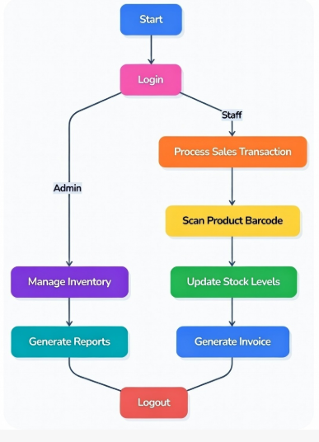

Figure 3.2.3: Activity Diagram

3.2.3 Sequence Diagram
A Sequence Diagram, part of the Unified Modeling Language (UML), is an interaction diagram that models the chronological sequence of messages exchanged among objects, actors, or components during the execution of a specific scenario or use case. It emphasizes the temporal order of interactions, lifelines of participating elements, and the flow of control or data in a dynamic system context.

3.3.3.1 Admin

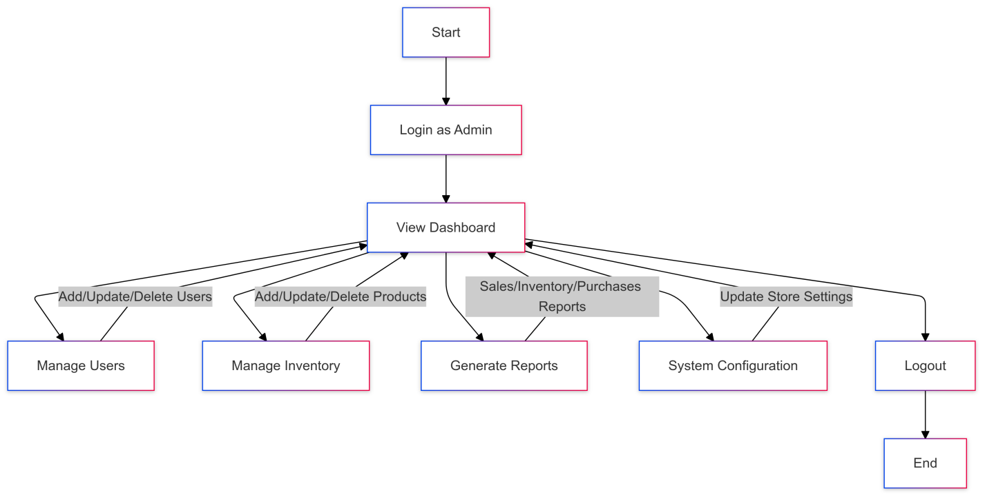

3.3.3.1 Staff

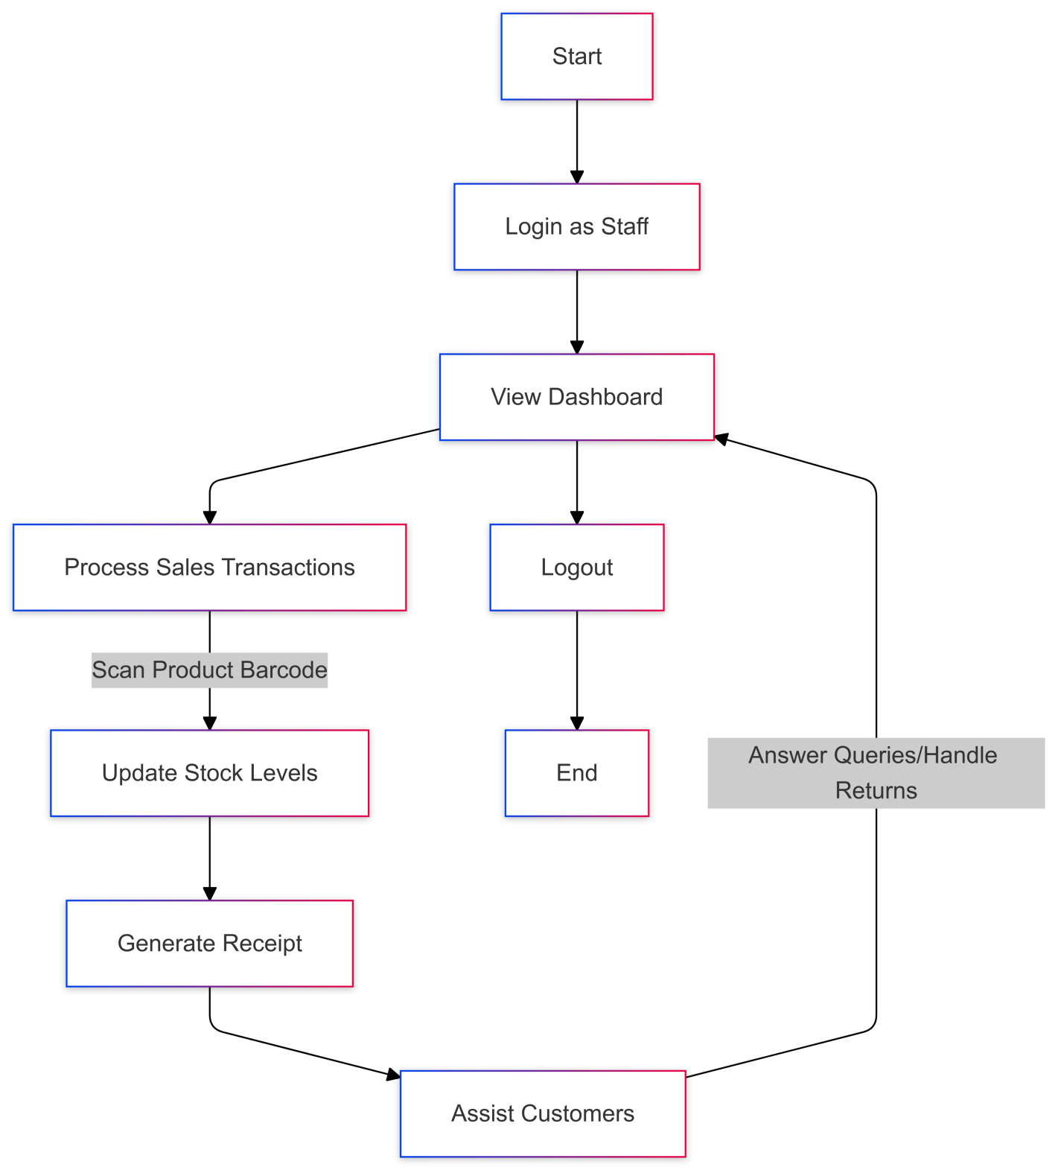

4. Data Structure
The system uses a strong data layout to keep information safe and organized.
Database Type:
- Relational structure.
- Main tables: Users, Products, Sales, Purchases.
Normalization:
- Uses third normal form to avoid repetition.
Tables:
Users:
user_id, username, password, role, email
Products:
product_id, name, details, price, quantity, category_id
Sales:
sale_id, user_id, date, total
Purchases:
purchase_id, supplier_id, date, cost
Connections:
- One User can have many sales
- Products and sales are linked by another table
- One supplier can have many purchases.
Backup:
- Daily backup system.
- Recovery steps in emergencies

5. USER INTERFACE DESIGN

5.1 Overview of User Interface
The system interface is clear, simple, and friendly. It allows staff and admin to work quickly without confusion.

5.2 Screen Images

5.2.1 Home Screen
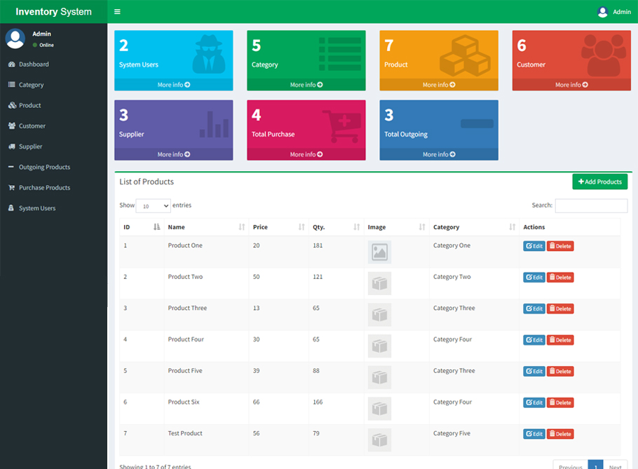

5.2.2 Login Screen
Logical screen design defines the layout and functionality of each screen in the INVENTORY MANGEMENT SYSTEM. It outlines how users interact with the system, ensuring clarity and efficiency.



6. Appendices

6.1 References
- IEEE. (2018). IEEE Standard for Software Engineering: Software Requirements Specifications (IEEE 830-1998). IEEE.
https://ieeexplore.ieee.org/document/730908
- Sommerville, I. (2011). Software Engineering (9th ed.). Addison-Wesley.
- Gamma, E., Helm, R., Johnson, R., & Vlissides, J. (1994). Design Patterns: Elements of Reusable Object-Oriented Software. Addison-Wesley.
- W3C. (2021). Web Content Accessibility Guidelines (WCAG) 2.1. W3C.
https://www.w3.org/TR/WCAG21/
- Mozilla Developer Network (MDN). (2021). Responsive Web Design. Mozilla.
https://developer.mozilla.org/en-US/docs/Learn/CSS/CSS_layout/Responsive_Design
- PHP Manual. (2021). PHP Documentation. PHP.net.
https://www.php.net/manual/en/
- MySQL. (2021). MySQL Reference Manual. MySQL.
https://dev.mysql.com/doc/

